Markov decision process (MDP), Bellman equations, policy evaluation using Monte Carlo, Policy iteration and Value iteration, Q-Learning, State-Action-Reward-State-Action (SARSA), Model-based Reinforcement Learning.

Introduction
Reinforcement Learning (RL) is a learning methodology by which the learner learns to behave in an interactive environment using its own actions and rewards for its actions. The learner, often called, agent, discovers which actions give the maximum reward by exploiting and exploring them.
A key question is – how is RL different from supervised and unsupervised learning?
The difference comes in the interaction perspective. Supervised learning tells the user/agent directly what action he has to perform to maximize the reward using a training dataset of labeled examples. On the other hand, RL directly enables the agent to make use of rewards (positive and negative) it gets to select its action. It is thus different from unsupervised learning as well because unsupervised learning is all about finding structure hidden in collections of unlabelled data.

Reinforcement Learning Formulation via Markov Decision Process (MDP)
The basic elements of a reinforcement learning problem are:
- Environment: The outside world with which the agent interacts
- State: Current situation of the agent
- Reward: Numerical feedback signal from the environment
- Policy: Method to map the agent’s state to actions. A policy is used to select an action at a given state
- Value: Future reward (delayed reward) that an agent would receive by taking an action in a given state
Markov Decision Process (MDP) is a mathematical framework to describe an environment in reinforcement learning. The following figure shows agent-environment interaction in MDP: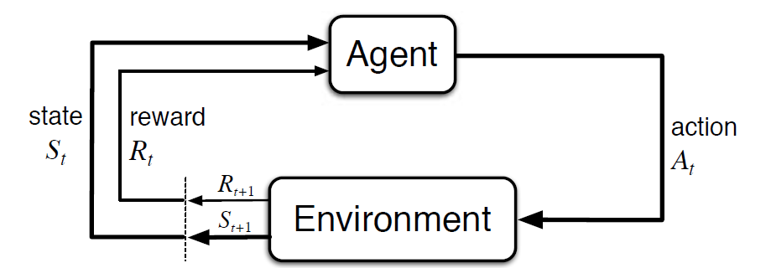

More specifically, the agent and the environment interact at each discrete time step, t = 0, 1, 2, 3…At each time step, the agent gets information about the environment state S_{t}. Based on the environment state at instant t, the agent chooses an action A_{t}. In the following instant, the agent also receives a numerical reward signal R_{t+1}. This thus gives rise to a sequence like S₀, A₀, R₁, S₁, A₁, R₂…
The random variables R_{t} and S_{t} have well defined discrete probability distributions. These probability distributions are dependent only on the preceding state and action by virtue of Markov Property. Let S, A, and R be the sets of states, actions, and rewards. Then the probability that the values of S_{t}, R_{t} and A_{t} taking values s’, r and a with previous state s is given by,
The function p controls the dynamics of the process.

Let’s Understand this Using an Example
Let us now discuss a simple example where RL can be used to implement a control strategy for a heating process.
The idea is to control the temperature of a room within the specified temperature limits. The temperature inside the room is influenced by external factors such as outside temperature, the internal heat generated, etc.
The agent, in this case, is the heating coil which has to decide the amount of heat required to control the temperature inside the room by interacting with the environment and ensure that the temperature inside the room is within the specified range. The reward, in this case, is basically the cost paid for deviating from the optimal temperature limits.
The action for the agent is the dynamic load. This dynamic load is then fed to the room simulator which is basically a heat transfer model that calculates the temperature based on the dynamic load. So, in this case, the environment is the simulation model. The state variable S_{t} contains the present as well as future rewards.
The following block diagram explains how MDP can be used for controlling the temperature inside a room:
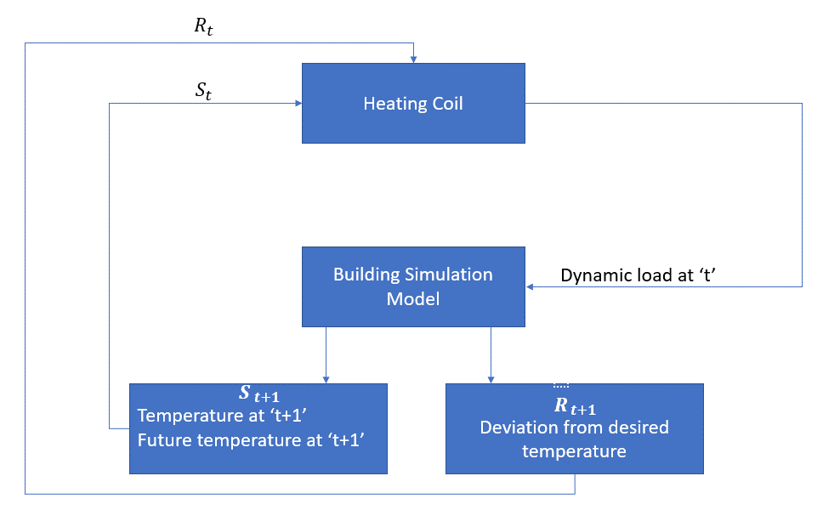

Limitations of this Method
Reinforcement learning learns from the state. The state is the input for policymaking. Hence, the state inputs should be correctly given. Also as we have seen, there are multiple variables and the dimensionality is huge. So using it for real physical systems would be difficult

Markov Decision Process (MDP) is a foundational element of reinforcement learning (RL). MDP allows formalization of sequential decision making where actions from a state not just influences the immediate reward but also the subsequent state. It is a very useful framework to model problems that maximizes longer term return by taking sequence of actions. Chapter 3 of the book “Reinforcement Learning — An Introduction” by Sutton and Barto [1] provides an excellent introduction to MDP. The book is also freely available for download.
Expressing a problem as an MDP is the first step towards solving it through techniques like dynamic programming or other techniques of RL. A robot playing a computer game or performing a task are often naturally maps to an MDP. But many other real world problems can be solved through this framework too. Not many real world examples are readily available though. This article provides some real world examples of finite MDP. We also show the corresponding transition graphs which effectively summarizes the MDP dynamics. Such examples can serve as good motivation to study and develop skills to formulate problems as MDP.

MDP Basics
In an MDP, an agent interacts with an environment by taking actions and seek to maximize the rewards the agent gets from the environment. At any given time stamp t, the process is as follows
- The environment is in state St
- The agent takes an action At
- The environment generates a reward Rt based on St and At
- The environment moves to the next state St+1
The goal of the agent is to maximize the total rewards (ΣRt) collected over a period of time. The agent needs to find optimal action on a given state that will maximize this total rewards. The probability distribution of taking actions At from a state St is called policy π(At | St). The goal of solving an MDP is to find an optimal policy.
To express a problem using MDP, one needs to define the followings
- states of the environment
- actions the agent can take on each state
- rewards obtained after taking an action on a given state
- state transition probabilities.
The actions can only be dependent on the current state and not on any previous state or previous actions (Markov property). Rewards are generated depending only on the (current state, action) pair. Both actions and rewards can be probabilistic.
Once the problem is expressed as an MDP, one can use dynamic programming or many other techniques to find the optimum policy.
There are much more details in MDP, it will be useful to review the chapter 3 of Sutton’s RL book.

Real World Examples of MDP

Examples of the Markov Decision Process
MDPs have contributed significantly across several application domains, such as computer science, electrical engineering, manufacturing, operations research, finance and economics, telecommunications, and so on.
Listed here are a few simple examples where MDP continues to play an imminent role:

1. Routing problems
MDP-based sequential decision-making is used to address routing problems such as those revealed in the traveling salesman problem (TSP). TSP can be broken down into the following components:
- Salesman = agent,
- Routes available = the actions that the agent can take while in the current state,
- Rewards = the costs of taking the specific routes, and
- Goal = the optimal policy that lowers the overall cost for the entire duration of the trip.

2. Managing maintenance and repair of dynamic systems
The maintenance and repair problems apply to dynamic systems like cars, buses, or trucks that deteriorate over time due to the actions in varied environments. The decisions, in this case, may refer to the act of doing nothing, performing repair tasks, or replacing the critical components of the vehicle. The formulation of this problem under MDP enables the system to choose actions that help minimize the vehicle’s maintenance cost over its lifespan.

3. Designing intelligent machines

Advancements in AI and machine learning have resulted in the extensive use of MDPs in robotics, complex autonomous systems, autonomous vehicles, automated systems, and so on. MDPs are used within reinforcement learning models that teach robots and machines how to autonomously learn and accomplish specific tasks.
For example, Google’s subsidiary, DeepMind Technologies, combines the MDP framework with neural networks and trains computing systems to play Atari games better than humans. The company has further used MDPs to teach machines to play board games such as AlphaGo. DeepMind Technologies has also exploited the MDP framework to teach simulated robots how to walk and run.

4. Designing quiz games
MDPs have been widely used to design quiz games with certain levels. At each level, a question is asked, which, if answered correctly, generates a monetary reward. As the level increases, the questions become tougher and attract higher rewards.
In quiz games, if the participant plays well and answers all questions correctly, then they get the reward for it and also a chance to decide whether to play the quiz from thereon or quit the game. If the participant quits, he can possibly keep all the earned rewards. However, if he chooses to play and fails to answer the question correctly at a certain level, he loses all the accumulated rewards. The goal of such games is to evaluate the actions of playing or quitting while maximizing the rewards.

5. Managing wait time at a traffic intersection
MDPs help in deciding the time duration of traffic lights. The objective here is to maximize the number of vehicles that can pass through traffic intersections while keeping a check on their wait times. It can be a two-way intersection where the traffic can flow in either direction, such as west or south, and so on. It is also assumed that the system has data on the number of vehicles approaching the intersection via sensors. The traffic lights, in this case, are red and green. Here, each step takes a few seconds (2 or 5). With MDPs, you can decide whether or not to change the traffic lights depending on the vehicles at the intersection and their wait times.

6. Determining the number of patients to admit to a hospital
Every day, a certain number of patients visit the hospital for various reasons. The hospital then has to decide how many patients it can admit while considering factors such as:
- the number of patients already admitted,
- the number of beds available, and
- the total number of patients that recover and get discharged daily.
While determining the number of patients to admit, the hospital also intends to maximize the number of patients that recover over a certain period. Both these objectives can be achieved by formulating MDPs for them.
Apart from the above real-life examples, MDPs are vital for optimizing telecommunication protocols, streamlining stock trading, and fine-tuning queue control in manufacturing sectors.

Reinforcement Learning branches from Machine Learning, it aims to train a model that returns an optimum solution using a sequence of solutions that have been created for a specific problem.
The model will have a variety of solutions and when it chooses the right one, a reward signal is generated. If the model performs closer to the goal, a positive reward is generated; however, if the model performs further away from the goal, a negative reward is generated.
Reinforcement Learning consists of two types of algorithms
- Model-free: This excludes the dynamics of the environment to estimate the optimal policy
- Model-based: This includes the dynamics of the environment to estimate the optimal policy.

What is Q-Learning?

Q-Learning is a model-free reinforcement learning algorithm. It tries to find the next best action that can maximize the reward, randomly. The algorithm updates the value function based on an equation, making it a value-based learning algorithm.
It’s like when you’re trying to find a solution to your current situation, to ensure you reap maximum benefits. The model can generate its own rules and even operate outside of the policy provided. Implying that there is no need for a policy, making it an off-policy learner.
An off-policy learner is when the model learns the value of the optimal policy regardless of the agent’s actions. An on-policy learner is when the model learns the value of the policy carried out by the agent, finding an optimal policy.
Let’s look at advertisements based on a recommendation system. Advertisements no-a-days are based on your search history or previous watches. However, Q-Learning can go a step further by optimizing the ad recommendation system to recommend products that are known to be frequently bought together. The reward signal is if the user purchases or clicks on the suggested product.
‘Q’ in Q-Learning stands for Quality. It represents how effective a given action is in gaining rewards.

Bellman Equation

The Bellman Equation was named after Richard E. Bellman who was known as the father of Dynamic programming. Dynamic Programming aims to simplify complex problems/tasks, by breaking them down into smaller problems and then solving these smaller problems recursively before attacking the larger problem.
The Bellman Equation determines the value of a particular state and comes to a conclusion on how valuable it is in that state. The Q-function uses the Bellman equation and uses two inputs: the state (s) and the action (a).
How do we know which action to take if we know all the expected rewards for every action? You can choose the sequence of actions that generate the best rewards which we can represent as the Q value. Using this equation:


- Q(s, a) stands for the Q Value that has been yielded at state ‘s’ and selecting action ‘a’.
- This is calculated by r(s, a) which stands for the immediate reward received + the best Q Value from state ‘s’.
- is the discount factor that controls and determines the importance to the current state
The equation consists of the current state, the learning rate, the discount factor, the reward linked to that particular state, and the maximum expected reward. These are used to find the next state of the agent.

What is a Q-table?

You can imagine the different paths and solutions that Q-learning provides. Therefore, in order to manage and determine which is the best, we use Q-table.
Q-table is just a simple lookup table. It is created so we can calculate as well as manage the maximum expected future rewards. We can easily identify the best action for each state in the environment. Using the Bellman Equation at each state, we get the expected future state and reward, then save it in a table to make comparisons to other states.
For example:

Q-learning Process

1. Initialize the Q-Table
The first step is creating the Q-table
- n = number of actions
- m = number of states
For example, n could be left, right, up, or down, whilst m could be start, idle, correct move, wrong move, and end in a game.

2. Choose and Perform an Action
Our Q-table should all have 0’s as no action has been performed. We then choose an action and update it in our Q-table in the correct section. This states that the action has been performed.

3. Calculate the Q-Value using Bellman Equation
Using the Bellman Equation, calculate the value of the actual reward and the Q-value for the action just performed.

4. Continue Steps 2 and 3
Repeat Steps 2 and 3 till an episode ends or the Q-table is filled.

